**PIZZA SALES SQL QUERIES**

**A. KPI’s**

**1. Total Revenue:**

SELECT SUM(total_price) AS Total_Revenue FROM pizza_sales;

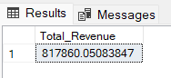

**2. Average Order Value**

SELECT (SUM(total_price) / COUNT(DISTINCT order_id)) AS Avg_order_Value FROM pizza_sales

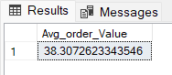

**3. Total Pizzas Sold**

SELECT SUM(quantity) AS Total_pizza_sold FROM pizza_sales

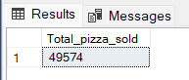

**4. Total Orders**

SELECT COUNT(DISTINCT order_id) AS Total_Orders FROM pizza_sales

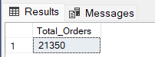

**5. Average Pizzas Per Order**

**select sum(quantity)/ count(distinct order_id) as Avg_Pizza_sales from pizza_sales;**

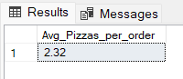

**B. Daily Trend for Total Orders  
SELECT**

**DAYNAME(STR_TO_DATE(order_date, '%d-%m-%Y')) AS Order_day,**

**COUNT(DISTINCT order_id) AS Avg_Pizza_sales**

**FROM**

**pizza_sales**

**WHERE**

**order_date IS NOT NULL**

**GROUP BY**

**DAYNAME(STR_TO_DATE(order_date, '%d-%m-%Y'));**

***Output:***

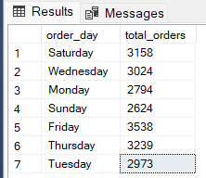

**C. Monthly Trend for Orders**

SELECT

MONTHNAME(STR_TO_DATE(order_date, '%d-%m-%Y')) AS Order_month,

COUNT(DISTINCT order_id) AS Avg_Pizza_sales

FROM

pizza_sales

WHERE

order_date IS NOT NULL

GROUP BY

MONTHNAME(STR_TO_DATE(order_date, '%d-%m-%Y'));

***Output***

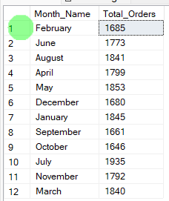

**D. % of Sales by Pizza Category**

SELECT

pizza_Category,

Round(SUM(total_price), 2) AS Total_Revenue,

ROUND(SUM(total_price) * 100 / (SELECT SUM(total_price) FROM pizza_sales), 2) AS PCT

FROM

pizza_sales

GROUP BY

pizza_category

ORDER BY

Total_Revenue DESC;

***Output***

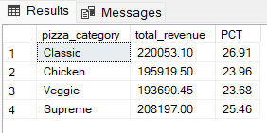

**E. % of Sales by Pizza Size**

select pizza_size, Round(SUM(total_price), 2) AS Total_Revenue,

ROUND(SUM(total_price) * 100 / (SELECT SUM(total_price) FROM pizza_sales), 2) AS PCT

FROM pizza_sales

GROUP BY pizza_size

ORDER BY Total_Revenue DESC;

***Output***

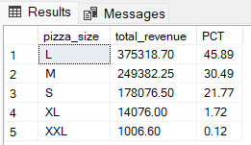

**F. Total Pizzas Sold by Pizza Category**

select Pizza_category,sum(quantity) as TotalPizza FROM pizza_sales

group by Pizza_category;

***Output***

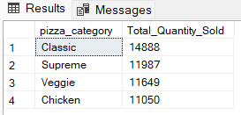

**G. Top 5 Pizzas by Revenue**

select pizza_name, sum(total_price) as Total_Revenew

from pizza_sales

group by pizza_name

order by Total_Revenew desc limit 5;

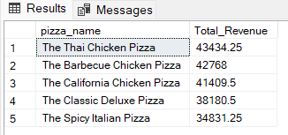

**H. Bottom 5 Pizzas by Revenue**

select pizza_name, sum(total_price) as Total_Revenew

from pizza_sales

group by pizza_name

order by Total_Revenew limit 5;

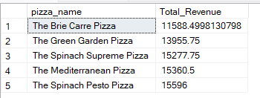

**I. Top 5 Pizzas by Quantity**

select pizza_name, sum(quantity) as Total_Quantity

from pizza_sales

group by pizza_name

order by Total_Quantity desc limit 5 ;

***Output***

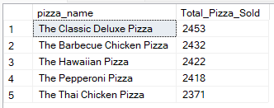

**J. Bottom 5 Pizzas by Quantity**

select pizza_name, sum(quantity) as Total_Quantity

from pizza_sales

group by pizza_name

order by Total_Quantity limit 5 ;

***Output***

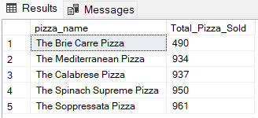

**K. Top 5 Pizzas by Total Orders**

**select pizza_name, Count(distinct order_id) as Total_Order_No**

**from pizza_sales**

**group by pizza_name**

**order by Total_Order_No desc limit 5 ;**

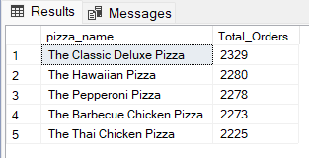

**L. Borrom 5 Pizzas by Total Orders**

select pizza_name, Count(distinct order_id) as Total_Order_No

from pizza_sales

group by pizza_name

order by Total_Order_No limit 5 ;

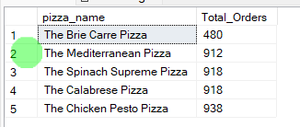

***NOTE***

If you want to apply the pizza_category or pizza_size filters to the above queries you can use WHERE clause. Follow some of below examples

SELECT Top 5 pizza_name, COUNT(DISTINCT order_id) AS Total_Orders

FROM pizza_sales

WHERE pizza_category = 'Classic'

GROUP BY pizza_name

ORDER BY Total_Orders ASC